AI ASSISTED CODING Assignment-6.1
HT.NO:2303A51664
Batch:14
Name:D.Sreeja
#Task-1:
Task Description #1 (AI-Based Code Completion for Loops)
Task: Use an AI code completion tool to generate a loop based program.
Prompt:
#Generate Python code to print all even numbers between 1 and N using a loop

Code:
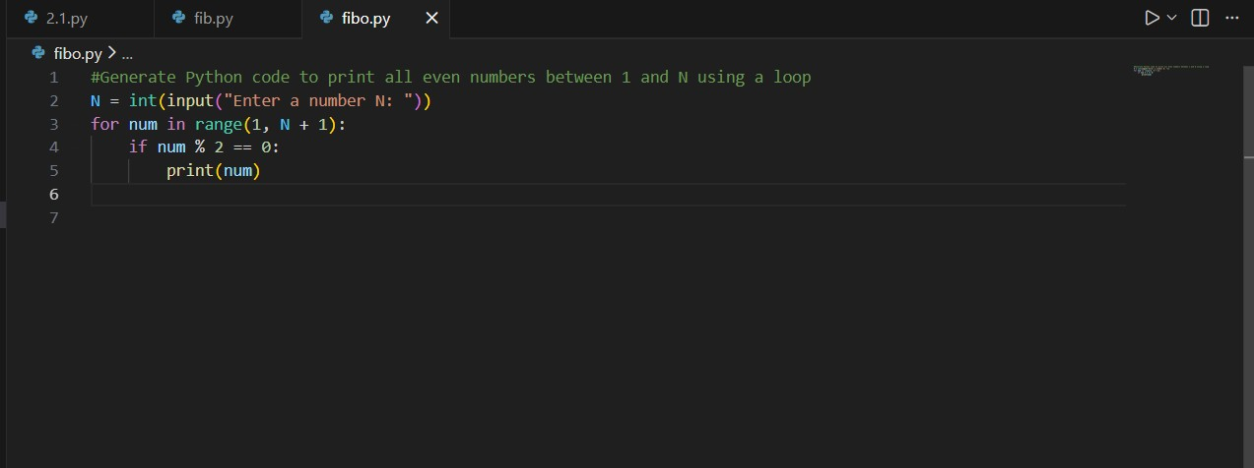

Output:
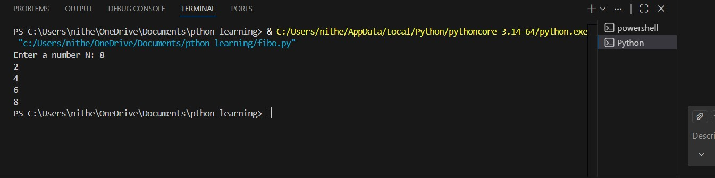

Justification:
The program uses a for loop to traverse numbers from 1 to N.
An if condition checks whether each number is even using the modulo operator.
Only numbers satisfying the condition are printed, ensuring correct identification of even numbers.

#Task-2
Task Description #2 (AI-Based Code Completion for Loop with Conditionals)
Task: Use an AI code completion tool to combine loops and conditionals.

Prompt:
#Generate a python code to count how many even and odd numbers are there in a List

Code:
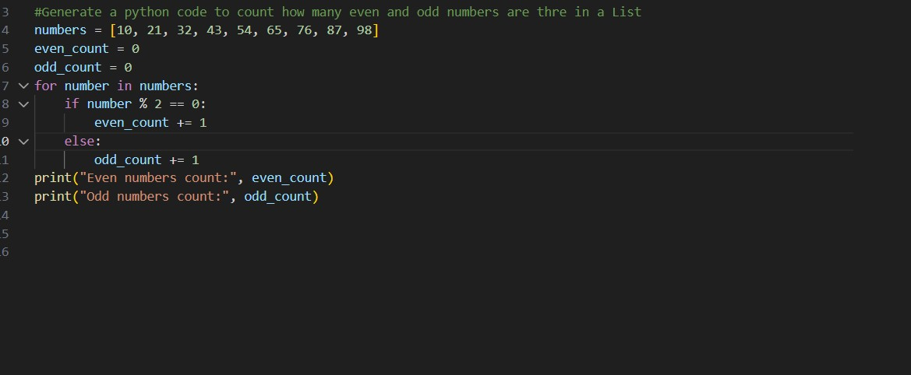

Output:

Justification:
The program uses a for loop to iterate through each number in the list.
An if-else conditional checks whether the current number is divisible by 2 to determine even or odd.
Separate counters are updated accordingly, and the final counts are displayed as output.

#Task-3:
Task Description #3 (AI-Based Code Completion for Class
Attributes Validation)
Task: Use an AI tool to complete a Python class that validates user

Prompt:
#Generate a Python class User that validates age and email using conditional statements Code:
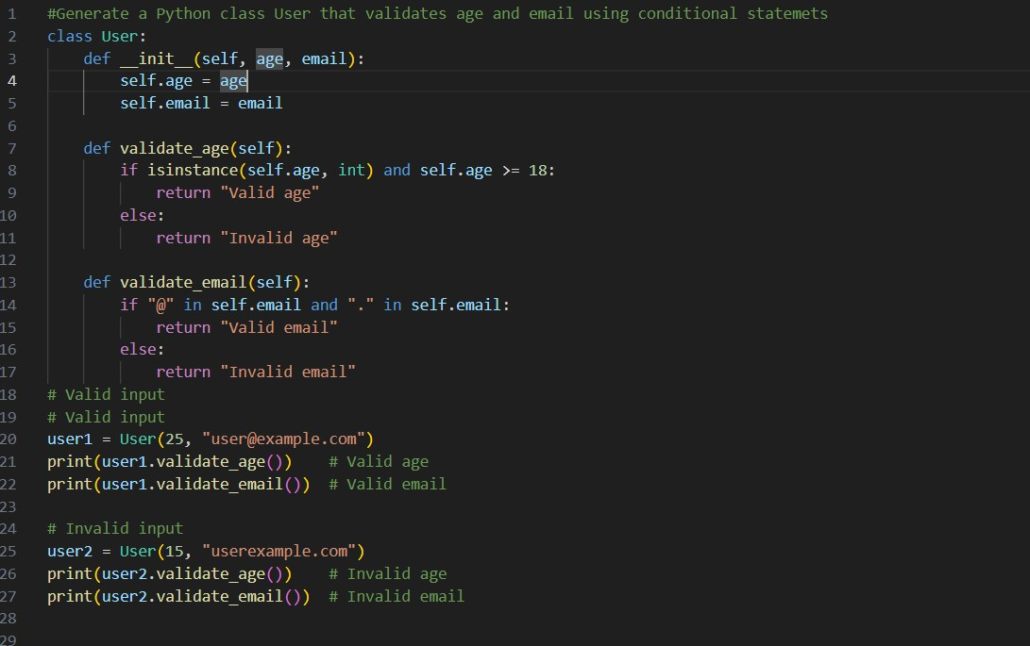
Output:
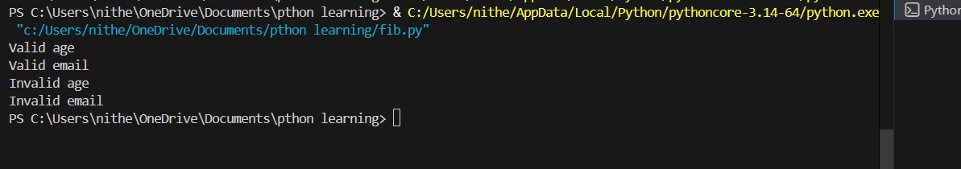

Justification:

The AI-generated User class uses conditional statements to validate age and email attributes based on predefined rules.
Separate validation methods ensure proper condition handling for both valid and invalid inputs.
Test cases confirm that the class correctly distinguishes between acceptable and unacceptable user data.

Task-4:
Task Description #4 (AI-Based Code Completion for Classes)
Task: Use an AI code completion tool to generate a Python class for managing student details.

Prompt:
#“Generate a Python class Student with attributes (name, roll number,marks) and methods to calculate total and average marks.”

Code:
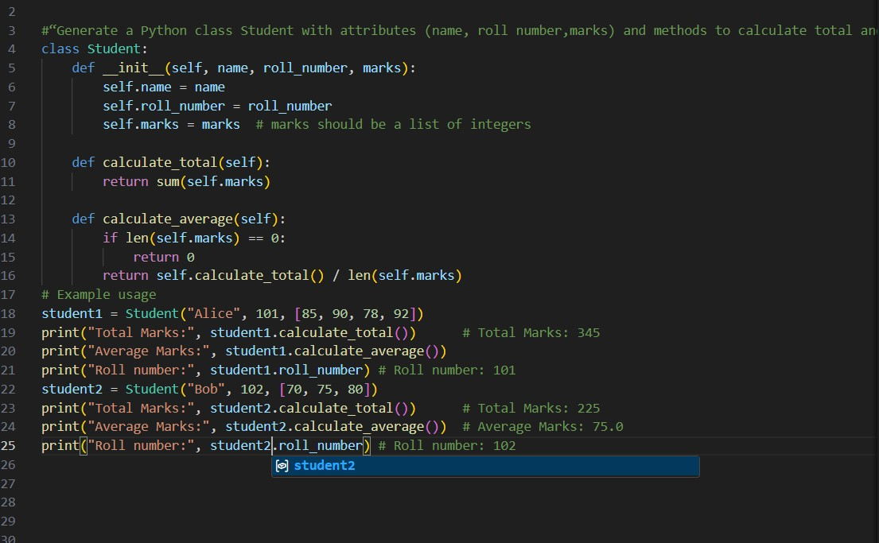

Output:
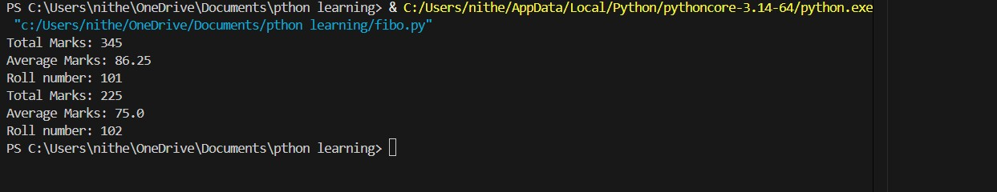
Justification:

The AI-generated Student class correctly defines attributes and methods, ensuring a complete and well structured class design.
Methods for calculating total and average marks verify the correctness of logic and data handling within the class.

Task-5:
Task Description 5 (AI-Assisted Code Completion Review)
Task: Use an AI tool to generate a complete Python program using classes, loops, and conditionals together.

Prompt:
#Generate a Python program for a simple bank account system using class,loops, and conditional statements

Code:
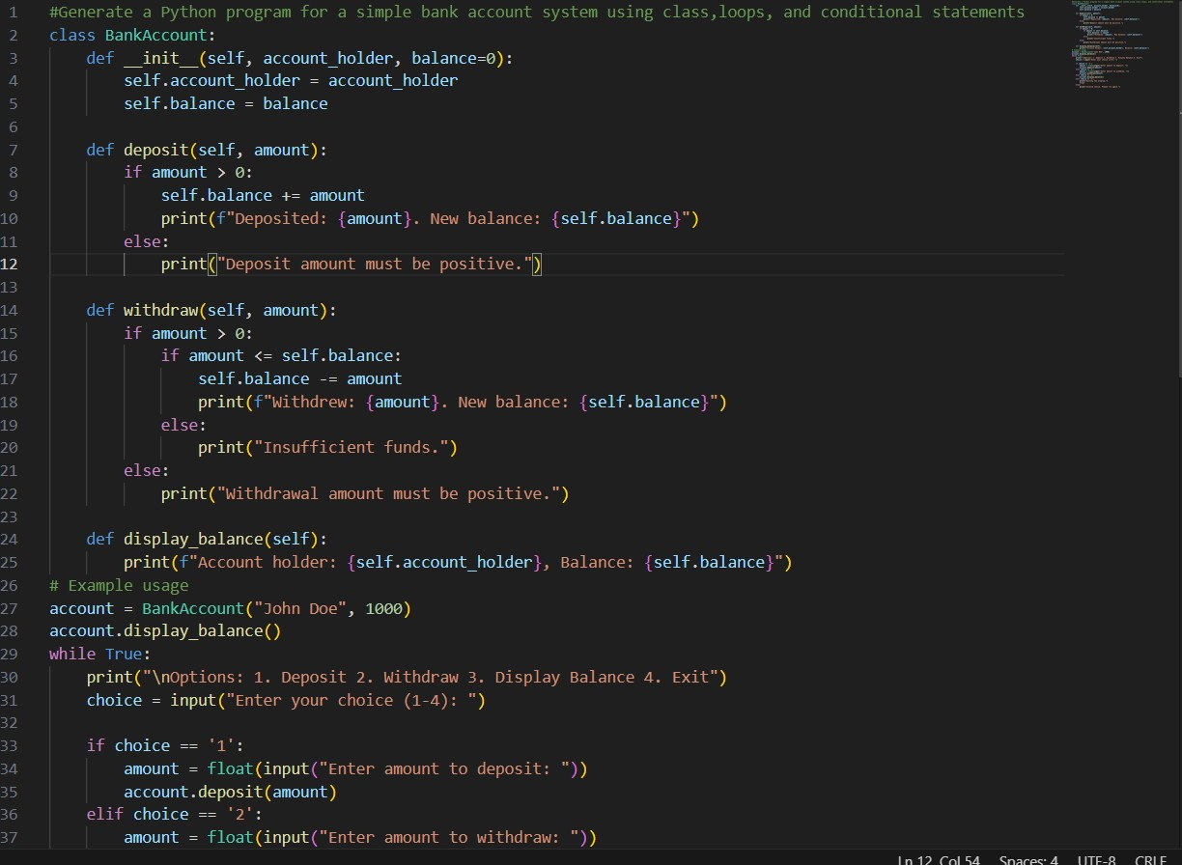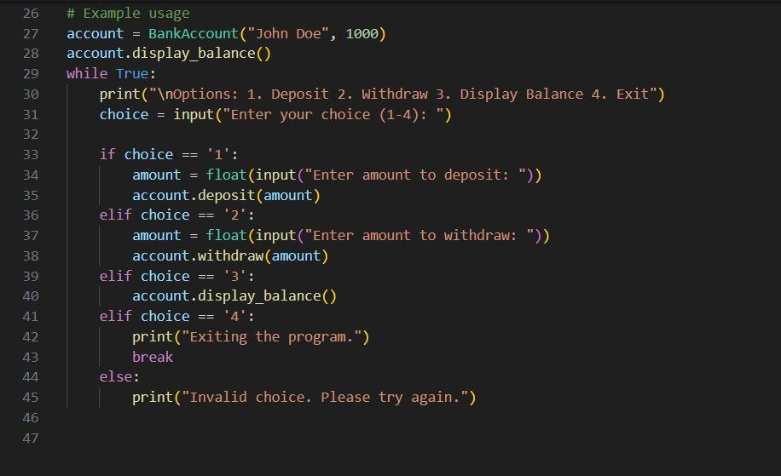

Output:
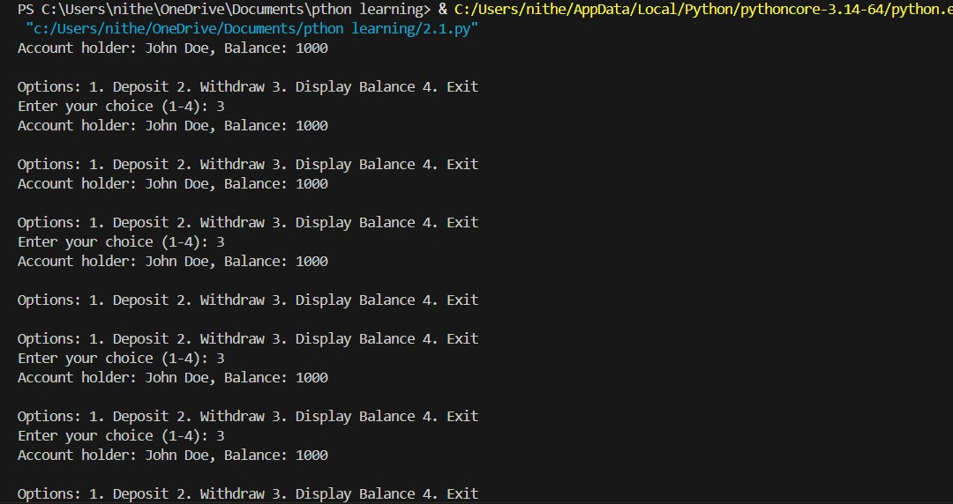

Justification:
The AI-generated bank account program integrates classes, loops, and conditional statements to model real-world banking operations.
Loops enable repeated user interactions, while conditionals ensure valid decision-making for deposits, withdrawals, and balance checks.

